

SAP Business One Implementation

Business Blueprint Documentation For
RMG Rent – A – Car Pte Ltd



Version: 1.0
Date: 27/08/2013



Revision History

Ver. # | Date | Prepared By | Significant Changes | Reviewed By
1.0 | 27/08/2013 | Boorla Srinivas | Initial URS Document | Maverick
Table of Content
1. Introduction 5
1.1 Overview 5
1.2 Company Profile 6
1.3 Scope 6
2. Financial Setup 7
2.1 Company Details – Basic Initialization 7
2.2 Financial Period 9
2.3 Chart of Account Structure 9
2.4 G/L Account Determination 10
2.5 Profit Center/Cost Center 19
2.5 Project 19
2.6 Others Finance Functions 19
2.7 Financial Reports 21
3. Administration 21
3.1 General Setting 21
3.1.1 General Setting – BP (Business Partner) 21
3.1.2 General Setting – Budget 22
3.1.4 General Setting – Display 23
3.1.5 General Setting – Font & Background 24
3.1.6 General Setting – Inventory 24
3.2 Document Numbering 25
3.3 Tax Setup 26
3.4 Document Setting 26
3.5 Payment Terms Setup 27
3.6 User ID 28
3.7 Alert Management 28
4. Banking Module 28
5. Fixed Assets 29
6. MASTER DATA SETUP 31
6.1 Business Partner Setup 31
6.1.1 Customer and Vendor Grouping 31
6.1.2 Business Partner Master Data 31
6.2 Vehicle (Item) Master Setup 34
6.3 Driver Master Setup 36
7. Purchasing Module 36
7.1 General 36
7.2 Other Functions in Purchase 38
7.2.1 Purchase Quotation - NA 38
7.2.2 Purchase Order - Yes 38
7.2.3 PO Goods Receipt – Yes for storage kits 38
7.2.4 PO Goods Return – Yes for storage kits 38
7.2.5 AP Invoice (Supplier Invoice) - Yes 38
7.2.6 AP Credit Memo - Yes 39
7.2.7 AP Down payment Invoice – Yes 39
7.3 Purchasing Report 39
7.3.1 Open Item Listing 39
7.3.2 Purchase Analysis Report 39
8. Inventory 40
8.1 Inventory Process 40
8.3 Functional in Inventory Module 40
8.3.1 Inventory Transaction – Good Receipt (N/A) 40
8.3.2 Inventory Transaction – Good Issue (N/A) 40
8.3.3 Inventory Transaction – Inventory Transfer (N/A) 41
8.3.4 Inventory Management - Alternative Items (N/A) 41
8.3.5 Inventory Management - Business Partner Catalogue Numbers - BP Tab (N/A) 41
8.3.6 Inventory Revaluation (N/A) 41
8.3.7 Stock Take (N/A) 41
8.4 SAP Standard Inventory Report 41
9. Fleet Management Add-On/Engine 42
9.1 Chauffeur Drive Process 42
9.2 Self Drive Process 47
9.3 Traffic & Parking Offence Management 54
9.4 Accident Claim Management 58
9.5 Service & Maintenance 63
9.6 Sales Commission 63
9.7 Vehicle Tracking 63
10. Price Setup 65
10.1 Base Price List 65
10.2 Special Price for Customer 66
Acknowledgement 67

1. Introduction

1.1 Overview

The document is created based on the discussion on at the premises of RMG Rent– A– Car Pte Ltd in Singapore. The discussion is in the presence of Business Development Executive.

The objective of having discussion and documentation is to have clear understanding on the requirements and deliverables items from RMG Rent–A– Car Pte Ltd and Abeo International, the project team.

Below is the schedule for URS:

Date | Topics | Attendees
15th May 2013 | Overview of the Current Business Process  Fleet Management | Maverick
17th May 2013 | Chauffeur Drive Services | Maverick
5th June 2013 | Self-Drive, Planning & Delivery | Maverick
7th June 2013 | Traffic & Parking offence management, Accident Claim management | Maverick
27th June 2013 | Service & maintenance | Maverick
2nd July 2013 | Accounts & Billing | Maverick & Finance Team
4th July 2013 | Sales Commision | Maverick
26th July 2013 | Financial topics | Maverick & Finance Team
6th Aug 2013 | URS Final Review | Maverick, Vincent and Finance Team
13th Aug 2013 | URS Final Review | Maverick, Vincent and Finance Team

1.2 Company Profile

These will be the companies that will be setup by Abeo International Pte Ltd.

Company Name | RMG Rent – A – Car Pte Ltd.
Address  Address Line 1:  Address Line 2:  Address Line 3:  Address Line 4:  Zip Code: Country: | 25 HOOT KIAM ROAD  Singapore 249407
Tel:  Fax:  Email:  Website: | 6235-1311  6235-5256  rentacar@singnet.com.sg  www.rmgrentacar.com.sg
Business Registration | Company Reg. No: 199100384R  GST Reg. No: M2-0097784-0

RMG RENT-A-CAR PTE LTD has positioned itself as a Solution Provider for all land transport related services in Singapore. Their main core business is to rent or lease Cars and also to assist in a suitable solution to customize to any special requirements.

1.3 Scope
- SAP B1 will be actively used to manage daily operations and finance.
- The modules to be implemented include:
- Accounting
- Financials
- Banking
- Fixed Assets
- Business partner master data
- Purchase – A/P
- Inventory
- Administration
- Fleet Management Add On/Engine

2. Financial Setup

2.1 Company Details – Basic Initialization

No. | Fields | Setting
1. | Chart of Account Template | User defined.  RMG will migrate their current COA into SAP.  Abeo will provide Template & RMG will update it.
2. | Local currency  **It is the operating currency in the system. | SGD
3. | System currency  ** It is the reporting currency. Users have an option to see your financial reports in another currency besides Local currency if it is necessary because in SAP each account is refined in Local, System or Specific Currency. In financial reports, you can only see via Local or System Currency | SGD
4. | Default Account Currency | SGD
Important: Company currency setup cannot be amended or changed anymore if there are transactions posted to the system.

5. | Display credit balance with negative sign.  ** Option cannot be changed once selected. | Yes
6. | Negative amount for all reverse transactions. [Yes/No]  Example: Normal (No)  Reversal → Debit Bank 100  Credit Expenses 100  - Total Debit and Credit Values increased.  Example: Negative (Yes)  Debit Expenses -100  Credit Expenses -100  - Total Debit and Credit Values do not increase. | No
  Debit Expenses 100
  Credit Bank 100
7. | What is the default valuation (costing) method you prefer?  The available valuation methods are:  - Moving Average: Calculate the inventory value by the item cost. By selecting this option, the item cost is updated dynamically by every inventory receipt posting.  - Standard Price: Calculate the inventory value by a fixed price. The item’s standard price should be set before you start working in your company.  ** A variance account required: - In certain scenarios, if there are differences between the standard price and the actual price in the purchasing documents, these differences are recorded in the variance account.  - FIFO: Calculates the inventory value by the first in first out method.  - Each inventory receipt transaction creates a “layer” of quantities linked to cost.  - Each inventory release transaction uses quantities and their corresponding costs from the first open layers. | NA
8. | Manage Item Cost as per warehouses?  [Yes] - Different warehouse can have different item cost.  [No] - One item cost for all warehouse | NA
9. | Need Purchase Accounts. | NA
10. | Allow stock to be released without Item Cost. | NA

2.2 Financial Period

Queries | Setting
What is the financial period of your company? | from : January  To: December
Number of Periods in one Financial Year  1 (year), 4 (quarters), 12 (months) | 12 months
Fiscal to be configure in SAP for initial setting: | 1st Jan 13 to 31 Dec 13  1st Jan 14 to 31 Dec 14

2.3 Chart of Account Structure

- In SAP B1, the Chart of Accounts is organized by drawers and levels. All drawers are level 1.
- These drawers, which have been defined by SAP and cannot be changed.

Drawer Name | Account Code
100000000000000 | Assets
200000000000000 | Liabilities
300000000000000 | Capital and Reserves
400000000000000 | Turnover
500000000000000 | Cost of Sales
600000000000000 | Operating Costs
700000000000000 | Non-operating income and expenditure
800000000000000 | Taxation and Extraordinary Items

- A maximum of 4 levels can be defined (including the drawer level).



100000000000000 – Assets

15000000 -- Current Assets

15101000 – Inventory
15101100 – Inventory (Item Group No 1)

15101200 – Inventory (Item Group No 2)

Seq. | Query | Customer Choice
1. | How is the structure of the COA, do them have different G/L account for Inventory, Sales, COGS per item group / warehouse? | Refer to chart of account
2. | Does your business currently use a segmented Chart of Accounts?  Select to specify if segments of information should be added to the standard account codes, such as division, region, cost center, and so on, for detailed transaction tracking and reporting. | No  Write Down the Segmentation if any  - Natural Code =  - Department :  Sales, marketing, Finance, HR, Admin and operation  - Region = North, South, East, West  12100000-01-001  Natural code – Department – Region
3. | How do you analyze your profit and loss currently?  For example: Item Group / Location / Others? | Consolidated Profit and loss  (By Profit center )
4. | How do you want to allocate the cost / revenue?  The allocation will be setup in G/L Account Determination.  (a) Warehouse  (b) Item Group | RMG will allocate the cost based on Item Group & Profit center.  User needs to provide the GL Accounts that map into the list of GL Account Determination after COA is setup. Otherwise Abeo will suggest and setup for RMG.  User needs to verify the GL Accounts during the UAT.

2.4 G/L Account Determination
GL Account Determination is use to define default G/L accounts for transactions created in SAP. All the transaction involves item posting, (AR Invoice) accounting entry will be captured by the system automatically from this setup.

***
Item groups (e.g. Services, consumables, Vehicles)
Item Group
Purpose of using item group: allocate the cost/revenue according to item group.
Eg.
Item Group: Consumable Items
Expense Account: 50101000 Purchases – Food/Sport/Stationary
Revenues Account: 40101000 Sales – Food/Sport/Stationary

If customer pays for a Food for $5000,  Posting Created:  Dr. Accounts Receivable 5000  Cr. Sales – Food 5000  Dr. COGS – Food 3000  Cr. Inventory – Food 3000 | If customer pays for a Stationary for $5000,  Posting Created:  Dr. Accounts Receivable 5000  Cr. Sales – Stationary 5000  Dr. COGS – Stationary 3000  Cr. Inventory – Stationary 3000

Warehouse

Purpose of using warehouse: allocate the cost/revenue according based on warehouse.
E.g.
Warehouse: Tuas
Expense Account: 420001 COGS – WH1
Revenues Account: 520001 SALES – WH1
Warehouse: Pejuru
Expense Account: 420002 COGS – WH2
Revenues Account: 520002 SALES – WH2

If customer buys a conversion kit at $5000 from WH1, Posting Created:
Dr. Accounts Receivable 5000
Cr. Sales – WH1 5000
Dr. COGS – WH1 3000
Cr. Inventory – WH1 3000

G/L Determination Account – Sales Tab
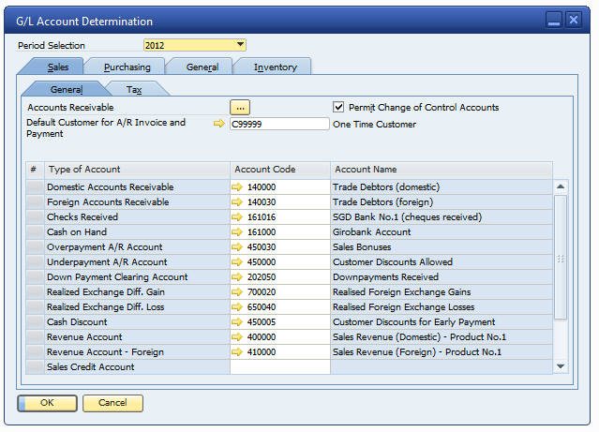
Note: The screenshot is for reference purpose, configuration will be done according to RMG Rent-A-Car Pte Ltd Chart of Account.

Field | Description/Activity | Setting
Domestic Accounts Receivable  Foreign Accounts Receivable | Define the Receivables account for domestic and foreign customers. Make sure the account is located in the Assets drawer and defined as a control account. The Receivables account for domestic and foreign can be the same G/L account.  Account: The code will provide in the COA listing. | Debtor Account  RMG will provide the GL Account code.
Checks Received | Define the default Checks Clearing account the system will use for incoming payments where the payment means is “Check”. The system debits this account in the incoming payment posting and credits the account when you deposit the check. In the incoming payment window you can change the Checks Clearing account manually.  Account: The code will provide in the COA listing. | RMG will provide the GL Account
Cash On Hand | Define the default Cash Clearing account the system will use for incoming payments, where the payment means is "Cash". The system debits this account in the incoming payment posting and credits the account when you deposit the cash. In the incoming payment window you can change the Cash Clearing account manually. You must define the accounts as Cash Account.  Account : The code will provide in the COA listing. | RMG will provide the GL Account
Overpayment A/R Account  Under Payment A/R Account | N/A | N/A
Down Payment Clearing Account | Define a default clearing account to be used when adding A/R down payment invoices. G/L accounts defined as control accounts cannot be selected. | RMG will provide the GL Account code.
Cash Discount | N/A | N/A
Sales Credit Account | Same as Revenue Account | RMG will provide the GL Account code.

G/L Determination Account – Purchase Tab

Field | Description/Activity | Setting
Permit Change of Control Accts | Select if you want to assign different control accounts to different vendors.  Yes. | Yes

Domestic Accounts Payable  Foreign Accounts Payable | Define the Payable account for domestic and foreign customers. Make sure the account is located in the Liabilities drawer and defined as a control account. The Payable account for domestic and foreign can be the same G/L account. | Creditor Account  RMG will provide the GL Account code.
Bank Transfer | Define a default account to use when paying by bank transfer.  Account: The code will provide in the COA listing. | RMG will provide the GL Account code.
Cash Discount | Define an account to use as default when a cash discount is used.  Account : N/A at the moment. | N/A
Cash Discount Clearing | Define an account to use as the clearing account when a cash discount is used.  Account: N/A at the moment. | N/A
Expense Account,  Expense Account - Foreign | Define an expense account for SAP Business One to use as the default when you post a transaction of domestic purchasing, for example, an A/P invoice. The system also selects this account as a default when you create new warehouses, item groups, and item master data records. The expense account is applicable only when you use non-inventory items. | Leave it blank. User to select relevant account code upon transaction creation.
Purchase Credit Account | Define an expense account for SAP Business One to use as default when you create a credit transaction for purchasing; for example, an A/P credit memo. This account is the default when new warehouses, item groups and item master data records are created. The purchase credit account can be the same as the Expense Account, if you do not wish to record credits to a separate account. | Expenses Account
G/L Determination Account – General Tab

Field | Description/Activity | Setting
Credit Card Deposit Fee | Define an account for posting fees for deposit of credit card vouchers. | Leave it blank. User to select relevant account code upon transaction creation.
Rounding Account | N/A | N/A
Period-End Closing Account | Define an account to be used when performing period and closing processes. | Leave it blank. User to select relevant account code during Period-End Closing.
Realized Exchange Diff. Gain, Realized Exchange Diff. Loss | N/A  N/A | N/A

G/L Determination Account –Inventory Tab
Field | Description/Activity | Setting
Expenses Account | Reflects the Non-Inventory final value and is recorded during the AP Invoice Transaction. | RMG will provide the GL Account code.
Revenue Account | Define the G/L account to be used when transactions of sales are created.  Account Code: Sales (Per Item Group) | RMG will provide the GL Account code.
Inventory Account | Reflects the inventory final value and is recorded in every inventory transaction in SAP Business One  Account Code: Inventory (STOCK Value per Item Group) | RMG will provide the GL Account code.
Cost of Goods Sold Account | Define the G/L account to be used when transactions of goods sold are created.  Account Code: COGS (Per Item Group) | RMG will provide the GL Account code.
Allocation Account | This clearing account is used as an offsetting account to the stock account in goods receipt POs and A/P credit memos. The balance of this G/L account reflects the total amount of open goods receipt POs and goods returns.  Account Code: Goods Received but not yet AP Invoiced (GRNI)  The code will provide in the COA listing | RMG will provide the GL Account code.
Variance Account | This G/L account is used only in a standard-price inventory system. In certain scenarios, if there are differences between the standard price and the actual price in the purchasing document, these differences are recorded in the variance account.  Account Code: N/A | N/A
Price Difference Account | Used in purchasing transactions only. Price differences between the base document and the target document are recorded in this account in certain scenarios.  Account Code: COGS (Per Item Group)  The code will provide in the COA listing | N/A
Negative Inventory Adjustment Acct  (Block negative stock) | This account is used only if inventory quantity is negative when the inventory posting takes place, and the document price is different than the moving average or the FIFO price (this account is not relevant for standard price valuation method). In these cases the moving average or FIFO prices are held static and the differences between these prices and inventory values as a result of adding new document are posted to this account.  We do not recommend using negative inventory from an accounting perspective. However, to use negative inventory, de-select the Block Negative Inventory field (in Administration → System Initialization → Document Settings → General tab).  Account Code: N/A for Prolife Biobank. | N/A
Inventory Offset – Decrease Account, Inventory Offset – Increase Account | N/A | (SAP Mandatory setting)  RMG will provide the GL Account code.
Sales Returns Account | N/A | N/A
Revenue Account – Foreign | N/A | N/A
Expense Account - Foreign | N/A | N/A
Exchange Rate Differences Account | N/A | N/A
Goods Clearing Account | An offsetting account to the allocation costs used when closing goods receipt POs or goods returns. In this case, no inventory entry is registered; however, a journal entry is created including this G/L account. | RMG will provide the GL Account code. Same with Allocation account.
G/L Decrease Account | An offsetting account to the Stock account used in Goods Issues and negative difference in Stock Postings (updates after inventory). You can change this account manually while creating its corresponding document.  Note: (Transaction posted from Inventory revaluation screen) | N/A
G/L Increase Account | Offsetting account to the stock account used in goods receipts and positive differences in stock postings (updates after inventory). You can change this account manually while creating its corresponding document.  Note: (Transaction posted from Inventory revaluation screen) | N/A
WIP Inventory Account | N/A | N/A
WIP Inventory Variance Account | N/A | N/A
Expense Clearing Account | N/A | N/A
Sales Credit Account | N/A | N/A
Purchase Credit Acct | N/A | N/A
Sales Credit Account – Foreign | N/A | N/A
Foreign Purchase Credit Acct | N/A | N/A

2.5 Profit Center/Cost Center

Seq. | Queries | Customer Choice
 | Is there a need to define profit center to evaluate profitability of the different departments? | Yes. ( Self Drive / Chauffer Drive)  **
If yes, how do you define your cost center? N/A

Category Code(8) | Name (20)
SD | Self - Drive
CD | Chauffeur Drive
GN | General

RMG have to be keyed in every transaction, if you have missed out, P&L will not be accurate.
To avoid this Abeo will make this as mandatory field, so that user will not

Note:

Information
- A profit center is a company unit or division that performs a specific business function. For example, a specific company unit might be responsible for manufacturing a product or providing a service.

2.5 Project

Seq. | Queries | Customer Choice
1. | Is there a need to analyst your Profit and Loss by project?  ** You have to be selecting the project code in every transaction, if you have missed out, P&L will not be accurate. | NA

2.6 Others Finance Functions

Journal Entry (In scope)
- This function allows user to create Journal Entries manually.
- The created Journal Entry will be recorded directly to the database and cannot be edited.
SAP B1 standard function.
Abeo recommended the standard JE transactions of SAP B1

Journal Voucher (In scope)
- Journal Voucher is a draft stage that creates no values in the general ledger.
- User can check the Journal Voucher before convert it to the Journal Entry.
SAP B1 standard function.
Abeo recommended the standard JV transactions of SAP B1.

Posting Template (In Scope)
- User can create fixed templates for transactions that frequently used.
- User calls out the template at Journal Entry or Journal Voucher screen.
- This feature is useful when user has to pass the same GL Item but in different values.
SAP B1 standard function.
Abeo recommended the standard JE Posting Template transactions of SAP B1.
Note : To be covered during training session.

Recurring Posting (In Scope)
- This function is useful when user has transactions that are occurring for every month or at certain period. User can define the posting frequency.
- Example: Rental or Payroll or PUB
SAP B1 standard function.
Abeo recommended the standard JE Recurring Posting transactions of SAP B1.
Note : To be covered during training session.

Exchange Rate Differences (out of Scope)
- N/A
NA

Conversion Differences (Not necessary)
- NA

Financial Report Templates (In Scope)
- Allow users to display Financial Reports according to the business needs.
- Financial Report Templates can be created for reports:-
  - Balance Sheet
  - Trial Balance
  - Profit and Loss Statement

Budget (out of Scope)
- N/A

2.7 Financial Reports

Seq. | Query | Customer Reply
 | Financial Reporting needed. | Yes
 | SAP Standard Financial Reports | o General Ledger Report  o Transaction Journal Report  o Tax Report  o Balance Sheet  o Trial Balance Report  o Profit and Lost report  o Aging Report  o Customer Statement of Account

3. Administration

3.1 General Setting

3.1.1 General Setting – BP (Business Partner)

** You can change this setting at any time.

Seq. | Queries | Customer Choice
 | Is it a requirement to setup credit limit for your customers?  If yes, where do you want to check the Credit Limit?  AR Invoice | Sales Order | Pick list | No
2. | Consider open deliveries before restricting any documents to be created. | N/A.
4. | Default Payment Term for Customer  - When creating new Customer, it will take this default Customer Choice | 14 Days
5. | Default Payment Term for Vendor  - When creating new Vendor, it will take this default Customer Choice | Upon receipt of Invoice.
6. | Activate Approval Procedures function. | Yes ( For A/R & A/P Invoices )
7. | Display Customer Balances by grouping against their Control Accounts? | Yes.

3.1.2 General Setting – Budget

** You can change this setting at any time.

Seq. | Queries | Customer Choice
1. | Is it a requirement to setup Budget for your company?  Annual or monthly budget? | No
2. | Where should the budget checking be set?  Purchase Orders | Goods Receipt POs | Accounting | N/A
3. | Alerts that is needed if over budget? | N/A

3.1.4 General Setting – Display

Seq. | Queries | Customer Choice
 | What would the default Customer Choice for:  - Language  - Color  - Length UoM  - Weight UoM  - Time Format [12H, 24H]  - Date Format  - Separator | - English (UK)  - SAP Signature Design  - MM  - KG  - 24 H  - Dd.mmm.yyyy
 | Decimal places (0…6)  - Amounts  - Prices  - Rates  - Quantities  - Percent  - Units  - Separator  - Thousand Separator | - 2  - 4  - 0  - 1  - 2  - NA  - .  - ,
3. | Currency code on the right. | No.
4. | Exchange Rate Posting methods:  Assumed the local currency is SGD dollar and the foreign currency is the US dollar.  (a). Direct (multiplying)  If you choose the Direct option, then on the Exchange rates table, you would enter  1.2465 as today‘s rate for the US dollar rate.  Example : 1.00 USD = 1.2462 SGD  (b). Indirect (dividing)  If you choose the Indirect option, then on the Exchange rates table, you would enter 0.8024 as today‘s rate for the US dollar rate.  Example : 1 SGD = 0.8024 USD | NA  Note : Follow SAP Default setting – Direct.

General Setting – Font & Background

Seq. | Queries | Customer Choice
 | Font type and size | Font Type : Arial  Font Size : 12
 | Background image to be display and how.  Image display :  Centralize / Full screen / Tile | Without background.

General Setting – Inventory

Seq. | Queries | Customer Choice
 | Manage item by serial no. or batches? | N/A
 | How to manage?  - On Every Transaction – you are required to assign serial / batch numbers for every inventory transaction.  - On Release Only – you are required to assign serial or batch numbers for inventory release transactions only. | N/A
3. | Serial No. will be unique by.  - None  - Mrf. Serial No.  - Serial Number  - Lot Number | N/A
4. | Automatically create Equipment Service Card? | N/A
5. | Basic Customer Choice for the batches
6. | Default warehouses for all the items | General Warehouse
7. | G/L Accounts are set by; | Item Group
8. | Auto. Add All Warehouses to New Items  - If you choose yes, for all new items, it will be tagged to the list of all physical and virtual warehouses in the database. You have to remove manually those warehouses that you do not need to use.  - If you choose No, no warehouse will be tagged to the item. You have to tag manually. | Yes

3.2 Document Numbering

Seq. | Queries | Customer Choice
1. | Do you want to have your own document numbering range? SAP B1 standard document numbering will start with “1” and the next running number will be “2”. | As per RMG document numbering series. First number to be advice.
2. | If Yes to Q1, please provide the range for documents listed below:  ** Other documents not defined will start the number from 1 | To be provided by RMG after the Blue print signoff.

** Follow same as AR Invoices
Document and Type | Standard SAP Abbreviation | Start Number | End Number
Sales Quotation - 23 | - | 1
Sales Order – 17 | - | 1
AR Invoice – 13 | IN | YYMM001 | YYMM999
AR Cash/POS Sales - 13 | IN
AR Credit Note - 14 | CN | YYMM001 | YYMM999 **
Delivery – 15 | DN | 1
Returns – 16 | RE | 1
AR DP Invoice - 203 | DT | YYYYMM00001 | YYYYMM99999***
Purchase Quotation - 54 | - | 1
Purchase Order - 22 | - | 1
AP Invoice – 18 | PU | 1
AP Credit Note - 19 | PC | 1
Goods Receipt PO - 20 | PD | 1
Goods Return PO - 21 | PR | 1
Journal Entry – 30 | JE | 1
Incoming Payment - 24 | RC | YYYYMM00001 | YYYYMM99999
Outgoing Payment - 46 | PS | YYYYMM00001 | YYYYMM99999
Goods Receipt - 59 | SI | 1
Goods Issue – 60 | SO | 1
Inventory Transfer - 67 | IM | 1

3.3 Tax Setup

Please see below for the standard tax codes used in SAP Business One.

OUTPUT TAX (Sales) |  |  | INPUT TAX (Purchase)
Code | Rate | Description | Code | Rate | Description
SO | 7% | Standard Rated | SI | 7% | Standard Rated
ZO | 0% | Zero Rated | ZI | 0% | Zero Rated
NO | 0% | Out of Scope | NI | 0% | Out of Scope
EO | 0% | Exempted | EI | 0% | Exempted

If you are using a tax code other than above, please provide the tax code together with the rate and description.

OUTPUT TAX (Sales) |  |  | INPUT TAX (Purchase)
Code | Rate | Description | Code | Rate | Description
GO | 0% | GST Not Applicable
AD | 3.5% | Asset Disposal

3.4 Document Setting

No. | Field | Customer Choice
1 | Calculate Gross Profit (%)  - Profit / Sales Price  - Profit / Base Price (Item Cost)  Example : gross profit/sales price x 100 = (40-30)/40 x 100 = 25% | Profit / Sales Price
2 | Manage Inventory by Warehouse  - If Yes, does not take the stock from another warehouse when the main warehouse does not have inventory.  - If No, takes stock from any available warehouse that has stock | Yes
3 | Block Negative Inventory  - [Yes] Do not allow release of item if stock level is 0.  - [No] Allow release of item if stock level is 0.  Recommended Answer = Yes. It's better to keep the correct stock level in the system and if it is FIFO. | Yes
4 | Response to Release of Inventory below the minimum level  - Without warning  - Warning only  - Block Release | Warning only
5 | Rounding Method  -By Document  When rounding occurs due to exchange rate conversions, put the rounding amount to the Discount field.  -By Currency  When rounding occurs due to exchange rate conversions, put the rounding amount to the Rounding field. | By Document
6 | Use Warehouse Address  - [Yes] It will take Warehouse address during PO  - [No] It will take Company address during PO | Yes
7 | Manage Freight in Documents  - [Yes] User can enter freight charge when create AR/ AP  - [No] User cannot enter freight charge when create AR/AP | N/A
8 | Block documents with earlier Posting Date  - [Yes] User can post a JE with earlier posting date  In each user authorization, you may decide to allow if this user is allowed or disallowed to submit documents with earlier posting date. | Yes
9 | Allow Future Posting Date  - [Yes] User can post a JE with later posting date  In each user authorization, you may decide to allow if this user is allowed or disallowed to submit documents with later posting date. | No
10 | Default Gross Profit % for Service Documents | 0.00

- This is the recommended setting for user environment. If there is any change, users can amend the setting according to their need.

3.5 Payment Terms Setup

Payment Terms | No of Days
30 Days | 30
60 Day | 60
COD | 0
14 Days | 14

Seq. | Query | Customer Reply
 | Which of the following date do you want to use to calculate for your due date?  - Posting Date  - Document Date | Posting Date + 2 Days(document date)

3.6 User ID

This window is used to create a new User Name and Password.

User ID and their Authorization Right

User ID | User Name | Password | License Type
PRO01 |  | 1234 | Professional
FIN01 |  | 1234 | Professional
 |  |  | Limited Licenses

3.7 Alert Management

Seq. | Query | Customer Reply
 | Conditions to set an alert.  Example :  - Alert for Purchase Orders that  are still open and not yet  received  - Alert for Sales Order that are  still open and not yet delivered  to customers | N/A
 | Recipients for each alert.

4. Banking Module

What is your house back account detail?

Bank Name | Bank Account No
Bank Name | UNITED OVERSEAS BANK LIMITED
Bank Account No | 924-347-687-5
Bank Branch Code | 311
Bank Code | 7375
SWIFT Code | UOVBSGSG
BANK ADDRESS | 1 COLEMAN STREET, #01-14, THE ADELPHI, SINGAPORE 238854
BANK BRANCH | UOB COLEMAN BRANCH
ACCOUNT NAME | RMG RENT-A-CAR PTE TLD

Seq. | Query | Customer Reply
 | Types of Payments | Cheque, Credit Card and Cash
 | Do you have any customer, who pays you in another currency than the Invoice Currency?  Example: Invoice in USD, Receipt in SGD? | No
 | Do you request your customer to pay the Advance payment before the goods being delivered to their premises? | Yes
 | When you receive checks from customer, do you debit bank directly?  Or you debit into separate checks account and debit bank after check clearance? | Debit Bank Directly.
 | When you receive Credit Card from customer, do you debit bank directly? Or you debit into separate credit card account and debit bank after check clearance? | Debit Bank Directly.
 | Do you have scenario to make GST payment some times after Supplier has invoiced you? | Could be.
 | Do you offer Cash Discount to your customer / vendor?  If yes, what Cash Account should be posted to? | Not apply at the moment.
 | Do you have the scenario of contra payment between A/R Invoice and A/P Invoice? | No allowed.
 | Do you have any supplier request your company to do the Advance Payment? | Yes

Fixed Assets

Standard SAP Business one configuration will be used to configure the Fixed Assets module for RMG.

- Asset tracking
- Asset profile and tagging
- Buying and selling
- Depreciation

6. MASTER DATA SETUP

6.1 Business Partner Setup

6.1.1 Customer and Vendor Grouping

You will need to assign a group when you create or maintain the master data for a business partner.

Customer Group | Vendor Group
Corporate | Contractors
Individual | Car Dealers
Event Company | Estate and Utilities
Principal | General Supplies
RMG Group | Freelancers
Government Bodies

6.1.2 Business Partner Master Data

Business Partner Master Data – Header and General Tab

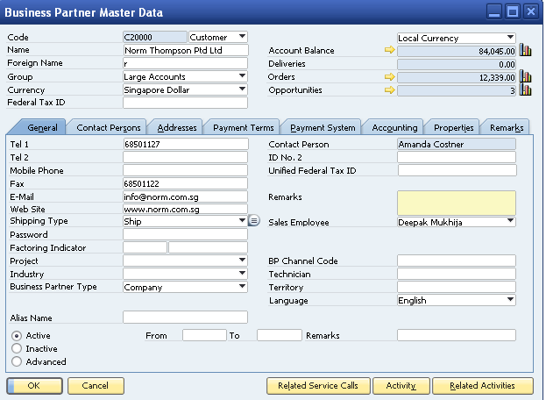
Screenshot is for illustration only.

Type of Field | Field Name
Mandatory | Customer/Vendor Code  (Maximum alphanumeric 15 characters)
Customer/Vendor Name
(Maximum alphanumeric 100 characters)
Customer/Vendor Group
(Maximum alphanumeric 20 characters)
 | Currency
Essential Data | Telephone/Mobile Number  (BP general reception telephone)  (Maximum alphanumeric 20 characters)
Email
(BP enquiry or general contact email.)
(Maximum alphanumeric 100 characters)
Contact Person
(Default Contact Person from Contact Person Tab) Will be used as emergency contact or vet contact person.
 | Sales Employee

Business Partner Master Data – Header and Contact Persons Tab

- Many contact persons can be created, but only 1 contact person is set as defaulted.
- Individual contact person are captured separately.
- For document printout, default contact person will be attn in Bill to Address.

Business Partner Master Data – Header and Addresses Tab

Type of Field | Field Name
Essential Data | Bill To Address
 | Ship To Address (Multiple) Ship to can be used for other address or location. If owner request to drop-off of their dog to another place other than the original address.

- Every Bill-To and Ship-To Address Name has to be unique.
- For document printout, bill to address will take Company Name; ship to address will take Address Name.

Business Partner Master Data – Header and Payment Terms Tab

Type of Field | Field Name
Essential Data | Payment Term
 | Credit Limit
 | Price List

Business Partner Master Data – Header and Payment System Tab

- Out of scope
- This is needed only for payment wizard.

Business Partner Master Data – Header and Accounting Tab – General Tab

Type of Field | Field Name
Essential Data | Account Receivables  This has to map with Debtor/Creditor control account

Business Partner Master Data – Header and Accounting Tab - Tax Tab
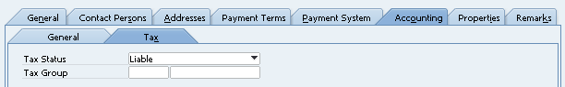
Screenshot is for illustration only.

Type of Field | Field Name
Essential Data | Tax Status = Liable
Tax Code
Tax code for sales and purchasing documents is defaulted to this setup.

Business Partner Master Data – Header and Properties Tab

- Properties Tab is a subsequent classification.

Business Partner Master Data – Header and Details Tab

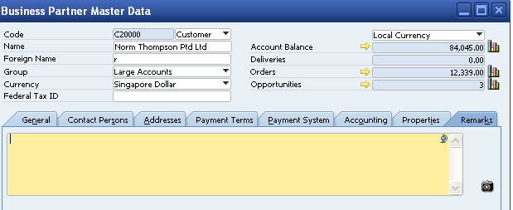
Screenshot is for illustration only.

- Detail Tab is customer detailed description and photos.

Screen Involved | No | Original Description | New Description
- Business Partner (General) | 1 | Name | Donor Name
- Business Partner (General) | 2 | Federal ID | Registration ID
 |  | Sales Employee
 |  | Contact Person | Applicant Name
 |  | Foreign Name
 |  | ID No
 |  | Federal ID 2
 |  | Remark
Remark |  |  | Other information
Contact Person |  | Contact ID | Name
 |  | First Name | NRIC/Passport No
 |  | Middle Name | Citizenship
 |  | Profession | Occupation
 |  | Telephone 1 | Contact No

6.2 Vehicle (Item) Master Setup

SAP Standard Item Master will be used to maintain Vehicle Master Data for RMG.
Necessary User defined fields will be defined in Item Master data under separate tab.
Item code will be used as vehicle number which is unique.

- Same vehicle plate can be used for different vehicles. For this need to create one more UDF.
- When query – based on vehicle plate. Show only active vehicles.
- Option should be provided to make it active or Inactive (Vehicle)
- Same number different vehicles.
- Vehicle Mileage: Needs to be updated in Vehicle Master every time whenever there is an update from various sources.

No. | Query | Reply
 | Different types of Items | - Inventory Items (Stock)  - Non-inventory items
 | What is the Item Category or Group being used now for your business? | Item will be categorized by Division
  Name (20)
  - Services
  - Consumables
  - Vehicles
 | How do you define the  Item Code?  Note: Maximum alphanumeric 20 characters. | Refer to the Vehicle Master Migration File
 | Do you need to transact in different Unit of Measure for same Item?  Example: buy in bulks, stocked in pcs, shipped in box | N/A for RMG.
 | Do you want to manage item by serial number? | N/A for RMG.
 | The same item having different UoM for purchasing, stocking and selling  ** Only single Inventory UOM can be maintained per item, and it must be kept in the smallest unit. | N/A for RMG.
 | Safety Stock Level, Maximum Stock Level for Item by Warehouse or Company Level. | N/A for RMG.
 | Do you have Consignment Warehouse? | N/A for RMG.

Vehicle Master:

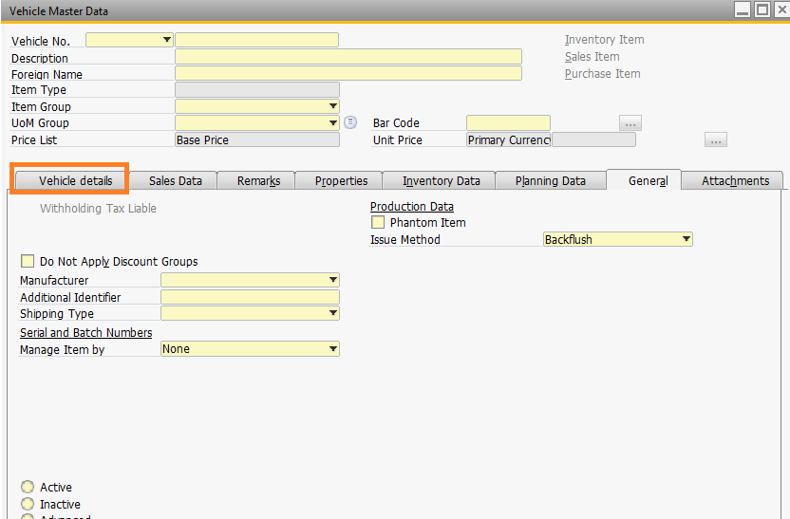

6.3 Driver Master Setup

Below customized screen will be used to maintain the Driver Master Data.

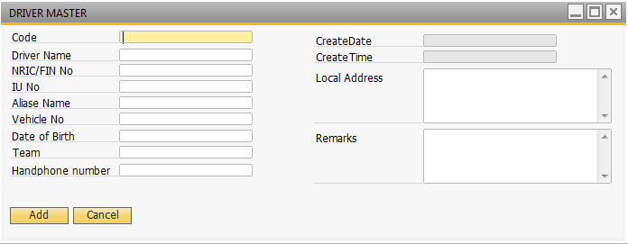

7. Purchasing Module

7.1 General
Q1. What is the process work flow to place a purchase order to supplier?
- Amount above 3000, then appropriation is required.
- Once appropriation is approved, then trigger a PO.
- Below 3000, create PO directly.

PO → Match PO with Quotation → AP Invoice → Payment

Q2. When do you initiate purchase process?
(a) When realize not sufficient stock for storage kits and other .
(b) Replenish stock in regular basic
(c) Purchase based on forecast (in scope in the training)
(d) case to case basic.

Q3. How do you return the goods to Supplier?
- Only for the defective storage kits.
- offset credit note.
- good issue to remove from inventory

Q4. Do you purchase Service from your vendor? Or raise PO for non-inventory purchase? For example: services, fixed assets purchase?
(a) Yes (b) No

Q 5. Do you purchase item in different packaging type for a same product?
For example: sometime purchase in loose and sometime purchase in pack.
(a) Yes (b) No

Q7: What is the process flow if you over receipt from vendor?
Take in excess.

Q8: When there’s freight charge, you or the supplier will bear the charges? How do you handle freight charge in accounting?

- Post to Expenses Account
- bear by Prolife

Q9: You can set authorization to confirm a purchase order. Is there any approval required during the sales process? Yes

Q10: What are the Forms you need to printout from system?
- Purchase Order – SAP format.

7.2 Other Functions in Purchase

7.2.1 Purchase Quotation - NA

- Standard PO screen in SAP B1.
- This will be used for purchase requisition by all departments.

7.2.2 Purchase Order - Yes

- Standard PO screen in SAP B1.
- The purchase order is a document used to request items or services from a vendor at an agreed upon price.
- When you enter a purchase order in SAP Business One, no value-based changes are posted in the accounting system. However, the order quantities are listed in inventory management.

7.2.3 PO Goods Receipt – Yes for storage kits

- Standard GRPO screen in SAP B1
- PO Goods Receipt feature is to receive the goods into warehouse; it updates the quantities, and creates an accounting journal (JE).
- GRPO is able to create from multiple PO. Use ‘Copy from’ function to perform multiple PO to 1 GRPO. User ‘Copy to’ to copy 1 PO to 1 GRPO.
- Other information needed:
- Batch No. : If item is a batch, this will be used for dog food items.
- Expiration Date

7.2.4 PO Goods Return – Yes for storage kits

- Standard GRPO screen in SAP B1
- Return damaged item to the vendor. Copy GRPO to Goods Return or copy from Goods Return from GRPO.
- Other information needed:
- Batch No. : If item is a batch, this will be used for dog food items.

7.2.5 AP Invoice (Supplier Invoice) - Yes
- Standard AP Invoice screen in SAP B1
- You can create an A/P invoice from multiple purchase orders and goods receipt POs. You cannot change any accounting-relevant data on an A/P invoice since it is the legal accounting document that generates entries in the general ledger.
- When you receive an A/P invoice, SAP Business One posts the related accounts for the vendor in the accounting system.

7.2.6 AP Credit Memo - Yes
- Standard AP CN screen in SAP B1
- AP Credit Memo is issued when GRPO is already converted to AP Invoice. It will reverse AP and Stock (if there are any)
- Copy AP Invoice to Credit Memo or copy Credit Memo from AP Invoice.

7.2.7 AP Down payment Invoice – Yes

7.3 Purchasing Report

7.3.1 Open Item Listing

- This report will help the user to view all open documents such as AP invoice (unpaid invoices).

7.3.2 Purchase Analysis Report

- The Purchase Analysis report provides detailed information about the purchases from vendors.

8. Inventory

8.1 Inventory Process

No. | Query | Reply
1 | What is the process to manage the inventory?
2 | Do you have item export from Inventory without related to any Sales document?  (a) Yes (b) No  What is the double-entry for the transaction? | N/A * Is it necessary to maintain the stock for consumable items (e.g. water bottles)
10 | At what frequency the stock taking or cycle count checks are carried out? (Annually, Monthly, etc.) | N/A
11 | What type of Inventory Report you need?  Please attach the format in softcopy. | N/A
12 | Do you perform inventory scrap regularly?  (a) Yes (b) No  If yes, any document needs to be printed out? | No
13 | Do you maintain the safety stock levels?  (a) Yes (b) No | No

8.3 Functional in Inventory Module

8.3.1 Inventory Transaction – Good Receipt (N/A)

- Good Receipt is used for receiving the stock without referring to any supplier invoice in SAP B1 (manual adjustment).
- Journal Entry:
Debit Inventory Account
Credit Inventory Offset – Increase Account

8.3.2 Inventory Transaction – Good Issue (N/A)

- Goods Issue is used for issuing the stock out without referring to any supplier or customer.
- Goods Issue will be used for the following scenario:-
- User can export the stock from Damage Warehouse or
- Export for special event usage.
- Journal Entry:
Debit Inventory Offset – Decrease Account
Credit Inventory Account

8.3.3 Inventory Transaction – Inventory Transfer (N/A)

- Inventory Transfer is used for transferring the stock from 1 warehouse to another.
- As discussed, Inventory Transfer will also be used for transferring stock from one Reserve WH to another. It is also used for transferring items for loan.
- Journal Entry:
Debit Inventory Account (To (receipt) warehouse)
Credit Inventory Account (From (issue) warehouse)

8.3.4 Inventory Management - Alternative Items (N/A)

- Allow user to define alternative items for item that are out of stock in a certain warehouse.
- User can select alternative items when creating marketing documents.

8.3.5 Inventory Management - Business Partner Catalogue Numbers - BP Tab (N/A)

- Out of scope

8.3.6 Inventory Revaluation (N/A)

- Applicable if company runs a perpetual system.
- This function enable user to reevaluate inventory value of the stock without affecting inventory quantity.

8.3.7 Stock Take (N/A)

- This function is to be used for entering the counted quantity after the stock take.
- And updating the counted quantity into in stock quantity in order to tally the system quantity with physical quantity in warehouse

8.4 SAP Standard Inventory Report

Standard SAP Inventory Reports

Fleet Management Add-On/Engine

9.1 Chauffeur Drive Process

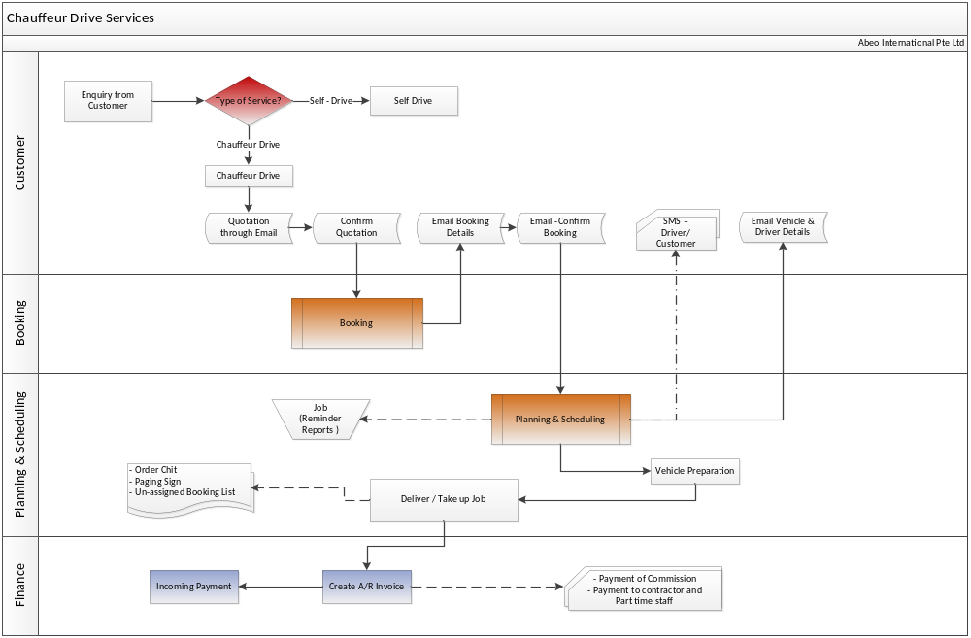

Overview of the Chauffeur Drive Process:
- Enquiry from customer
- Send Quotation through email
- Quotation confirmation from Customer
- Enter Booking details
- Send Booking details to customer and get the confirmation
- Planning & Scheduling – Assign Vehicle & Driver
- Send SMS notification to Driver & Customer before the Job
- Vehicle preparation & Delivery
- Billing - Invoice will be generated and payment will be collected before or after or in between the Job.

- Each company may have different address and different contact person and different Project.
- There may be ad-hoc job requirements and multiple events.
- Type of Client category – End user, Agent, corporates, Internal (Other companies under the group of RMG) and Principals (Booking through certain company and provide the services to them).

Forms:
- Chauffer Order Chit ( After assigning the Driver this form will be printed and Order No. will be auto generated) – Form CD1A
- Form CD2 – Paging Sign
Query: Operation supervisor need a report to show all the confirmed booking details. (Excluding contractors assignments)

UI – Chauffeur Drive

Booking :
Open
Cancel – with charges
Cancel – without charges
Close

Below is the screen to enter booking details.
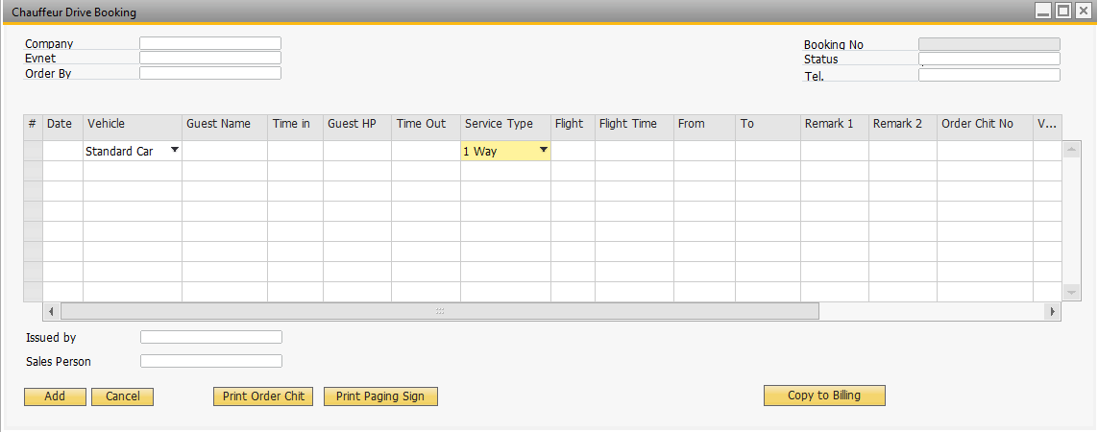
Click: Copy to Billing

Copies the booking details to Billing (A/R Invoice)

Planning & Scheduling

- In this module user will assign the vehicle and Driver. Below is the screen for Reservation.
- User can able to see list of all bookings, before assigning.
- Select relevant booking (Check box) and Assign the vehicle and driver to reserve the vehicle.
- Formatted search will be provided to see only list of available vehicles, so that user can easily select the vehicle and reserve it for the booking.

Click: Search – show list of open Bookings

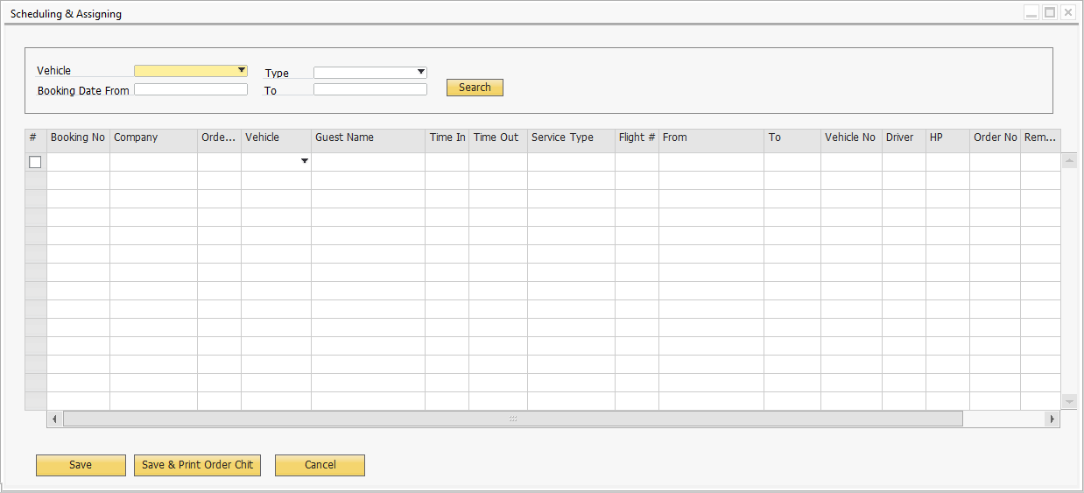
Click: Save & Print Order Chit
After assigning the Driver and Vehicle no. user will print the Order chit.

Order No. will be auto generated.

Billing

- Update the Usage (May be additional cost (e.g. Additional stops, delay charges, extension of service, attraction entrance fees - Item Master
- Ability to update and overwrite all the fields of the Booking Details screen
- Standard SAP Business One - A/R Invoice screen will be used for Billing
- In the AR Invoice it will show only the total Amount not all the Booking details
- Booking details is a separate report it will be attached along with A/R Invoice.
- Two copies of attachment : One for Admin and other one is for customer.
- Necessary User defined fields will be created in A/R Invoice to capture all the booking details.

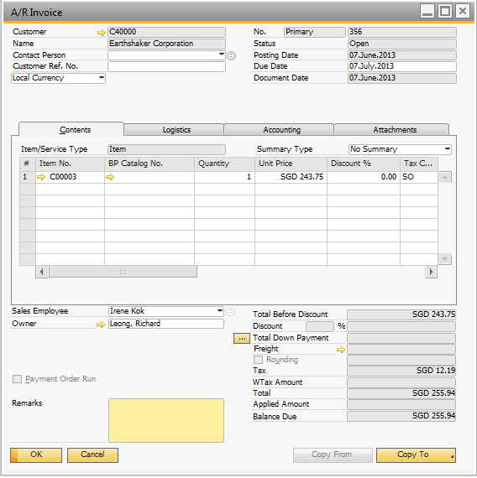
Note: The screenshot is for reference purpose, configuration will be done according to RMG Rent-A-Car Pte Ltd.

Notifications

SMS, E-mail and Reports

SMS Notifications for Customers: Option will be provided in the Business Partner Master data to send SMS Yes|No. Default is No.
There should be alert for the outstanding assignments without driver at schedule time every day - Send Alert via email.

Job Schedule:

Monday to Thursday
Example: 9am – Print a complete today’s order un-assigned
12pm – Print from 12pm today + next day until 6pm
4pm – Print from 4pm today + next day 11.59pm
Friday:
Example: 9am – Print a complete today’s order un-assigned
12pm – Print form 12pm today + until Monday 12pm
4pm – Print from 4pm today + until Monday 12pm

Saturday:
Example: 9am today + to Monday 12pm

Format will be same as Excel Output – Order details.

- After assigning the Driver and Vehicle no. user will print the Order chit. Once the order chit has printed, set the flag to Printed YES. If any changes to booking details for the subsequent print it has to prompt message to the user that
“Do you want to print again YES|NO?”

9.2 Self Drive Process

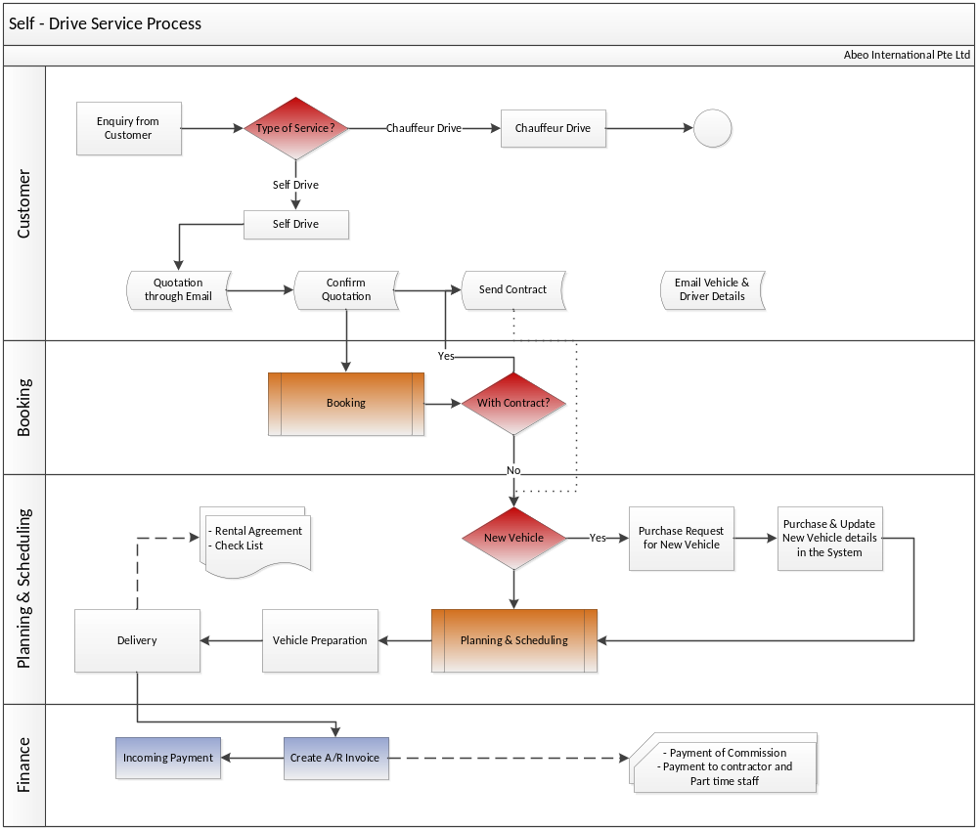

Overview of the Self-Drive Process:
- Enquiry from customer
- Send Quotation through email
- Order confirmation ( with or without contract)
- If with contract RMG will send contract to customer to sign for confirmation
- If new vehicle, purchase and update new vehicle details in the system (Vehicle Master).
- Update Booking details (New vehicle) & Reserve the vehicle
- Vehicle preparation & Delivery
- Rental agreement (RA) & Check list - at the point of delivery.
- Contract will be allocated to customer first then prepare the Rental Agreement
- After confirmation of the Rental Agreement, Rental agreement needs to be uploaded in the system
- Two uploads one is Post-delivery & Post return (RA).
- Generate Invoice & collect the payment from the customer
- Long term rental– Generate recurring invoices on monthly basis and send to customer.

Self – Drive – UI

Booking: Below is the screen to enter booking details.

- Driver Details Tab
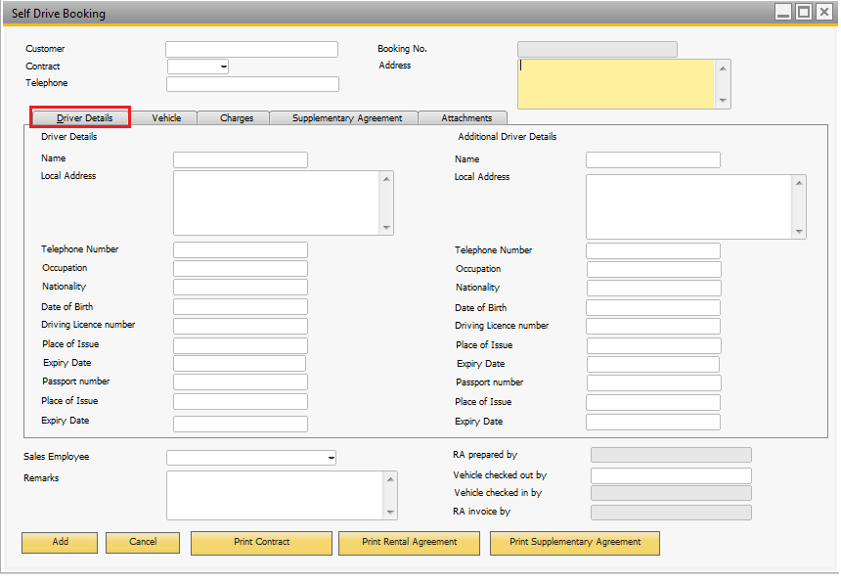
Click this tab to enter driver details.

- Vehicle Details Tab

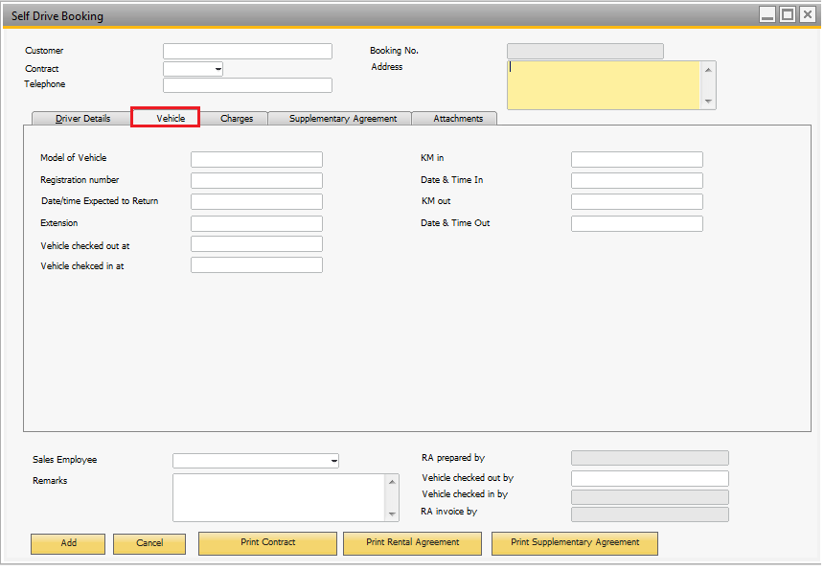
Click this tab to enter Vehicle details.

- Charges Tab

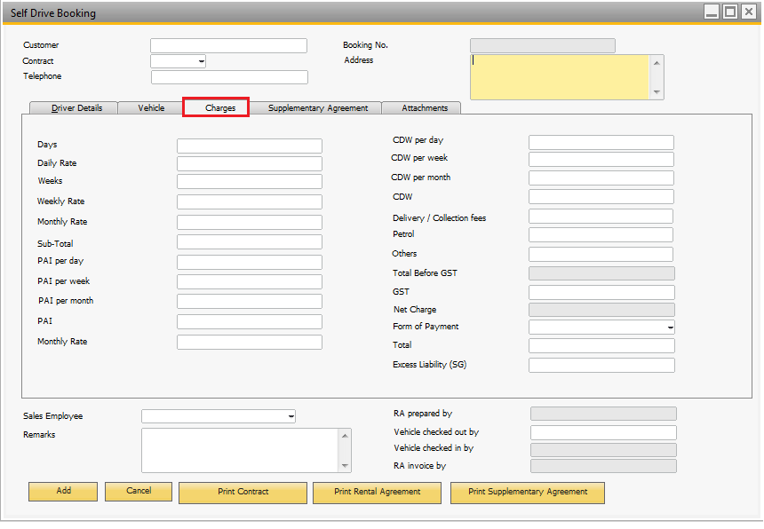
Click this tab to charges.

- Supplementary Agreement Tab
Click this tab to enter Supplementary Agreement details

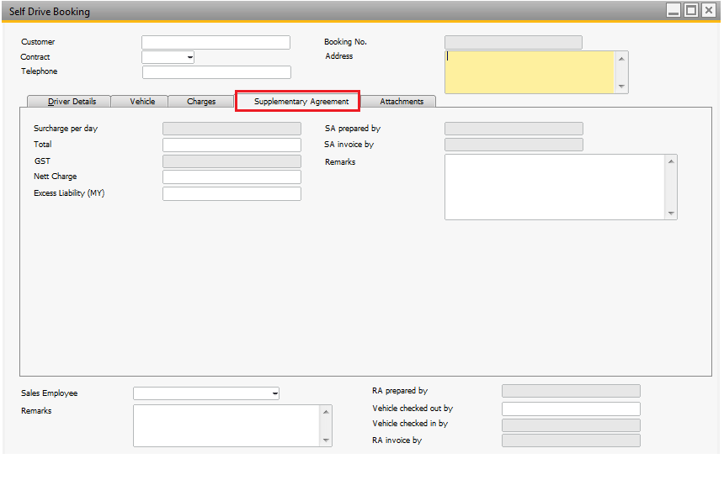
- Attachements Tab
Attach all the necessary documents related to Self-Drive process under this tab.
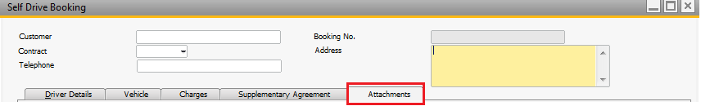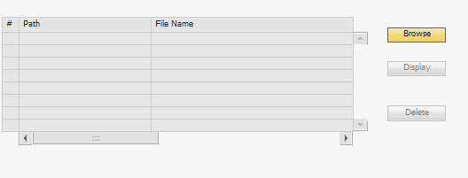

Reports:

- Rental Agreement
- Supplementary Agreement
- Order Check List ( IN & OUT )
- Contract

Click these Icons to print reports.

 | Click the Preview icon to preview Report
 | Click the Print icon to print the Report
 | Click the [PDF] icon to save as PDF format.

Planning & Scheduling

- In this module user will assign the vehicle and Driver and reserve the vehicle. Same screen as Chauffer Drive but fields will be different according to Self-Drive.
- User can able to see list of all bookings, before assigning.
- Select relevant booking (Check box) and Assign the vehicle and driver for the booking.
- Formatted search will be provided to see only list of available vehicles, so that user can easily select the vehicle and reserve it for the booking.

Billing

- Short term rental calculate the Billed Amount based on no. Of days vehicle used
- Long term rental calcuate the Billed amount based on Monthly
- There may be adhoc short term rental also
- After the Billing, Booking Order will be closed manually by user.
- Ability to update and overwrite all the fields of the Booking Details screen
- Standard SAP A/R Invoice screen will be used for Billing
- Necessary User defined fields will be created in A/R Invoice to capture all the booking details.
- Recurring Billing cycle – Monthly for long term
- Send bill to customer twice a month
- Advance Payment from customer -

Below UI to list down the Recurring transactions based on Booking Order Status which is Open (Monthly)

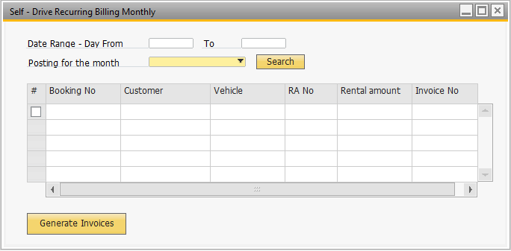
Select Invoice posting month – default will be current month
Click – to generate Invoices
Option to select

- List down the Recurring transactions based on Booking Order Status which is Open
- Default will be current month, but user can able to change the month
- Send bill to customer twice a month.
- If the contract falls between date rage generate Invoices in batches.
- Every rental agreement there is a tag to show whether the billing is recurring, everymonth.
- There should be an option to exclude the transactions
- Provide Date Range ( Day eg. 1st 10th) - Delivery date will be used

Note: The screenshot is for reference purpose, configuration will be done according to RMG Rent-A-Car Pte Ltd.

Notifications

- There should be alert for the outstanding assignments without driver or vehicle 10days in advance - Send Alert via email.
- 3months before expiry - Notification email should be sent (Alert) (Email to the Sales Person) - Just to notify the Sales person about the contract expiry, with vehicle details & current pricing.
- Email Notification : for long term – start of the rental date + 3 days – If the Invoice for the next rental period is not geneated send an email.

- Example : Rental start on 1st January 2012 ; 1st Invoice should be generated by 4th Jan 2012. If not then send alert email.
- Rental start 1st Jan 2012 ; 6th Invoice should be generated by 4th June 2012. If not then send alert.
- ( Date to consider in A/R Invoice is Document Date ( this will be posting date + 3 days)

Job Schedule:

Monday to Thursday

Example: 9am – Print a complete today’s order un-assigned
12pm – Print form 12pm today + next day until 6pm
4pm – Print from 4pm today + next day 11.59pm
Friday:
Example: 9am – Print a complete today’s order un-assigned
12pm – Print form 12pm today + until Monday 12pm
4pm – Print from 4pm today + until Monday 12pm

Saturday:
Example: 9am today + to Monday 12pm

Format will be same as Excel Output – Order details.

9.3 Traffic & Parking Offence Management

This Module will be used to maintain Traffic & Parking Offence details. Below are the steps.

STEP 1
Select from Category
- RA (Self Drive) – (RA – Rental Agreement)
- Staff (CD or Errand) (CD – Chauaffer Drive)
Enter the RA/CD number or indicate Errand
Populate details if RA or CD number is provided

Option 1 Self Drive
In the case of option 1 RA, there could be multiple driver records, option to select driver 1,2 or 3.
Auto-populate the selected driver profile and details (Driver Name, Driving lic no., DL Expiry date, Passport no., PP Expiry date, Driver contact no., Driver Address)
Auto-populate customer details (Name & Attn & Contact number)

Option 2 Staff
In the case of option 2 Staff
Select the driver from list
Auto populate staff details details (Driver Name, Driving lic no., DL Expiry date, Passport no., PP Expiry date, Driver contact no., Driver Address)

STEP 2
Enter traffic offence details
- Vehicle number (Disp - Make, model, cc, YOM)
- Agency (TP, HDB, LTA, URA,Sentosa,PSA and Others)
- Type of offence (Speeding, Parking, Traffic Light, ERP,Others)
- Notice number
- Date
- Time
- Location
- Demerit point
- Fine amount
- Expiry date of the notice
- Attach notice image
- Admin find out who is the driver and proceed with the submission to authorities
- Return to the system to update status
STEP 3
- Submission date – USER ID LOG
- Submission mode (Web Portal, Email, Fax, Registered mail)
- Attach Submission doc
- Remark

OUTPUT
- Option to print Submission report with offence details and driver paritculars ( Provided by Maverick)
- Weekly report for outstanding offence expiring in the week. Job run on Sunday and email. (Step 2 Items 1 to 6 and 10 )

Query UI for customer/Driver historical data:
- Trans history
- Traffic offence
- Accident history

UI for Traffic & Parking Offence:

- Drive/Customer Details Tab

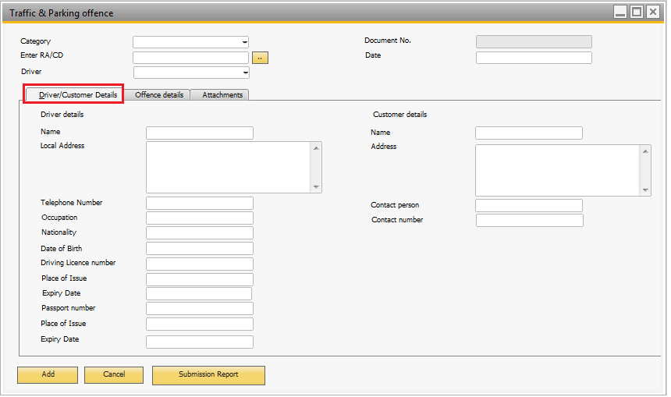

- Offence Details Tab

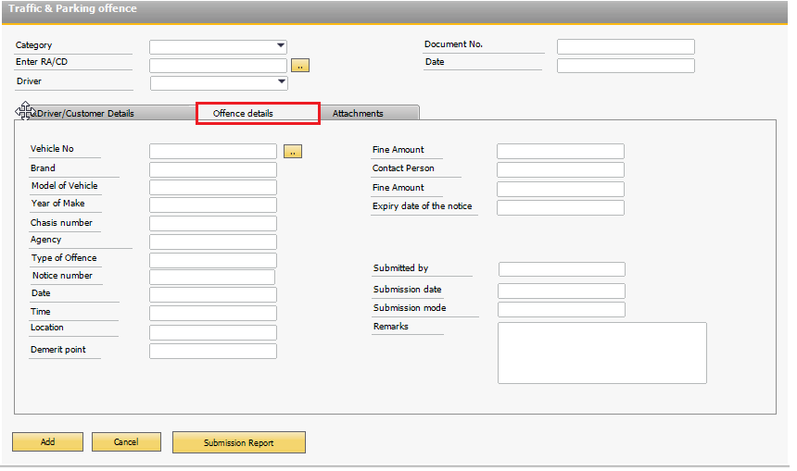

- Attachements Tab
Attach all the necessary documents related to Traffic & Parking Offence under this tab.

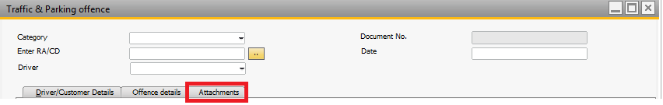

Reports:

- Submission Report

Click these Icons to print reports.

Click the Preview icon to preview Report
Click the Print icon to print the Report
Click the [PDF] icon to save as PDF format.

9.4 Accident Claim Management

This Module will be used to maintain Accident Claim details.

STEP 1
Select from Category
- RA (Self Drive)
- Staff (CD or Errand)
Enter the RA/CD number or indicate Errand
Populate details if RA or CD number is provided

Option 1 Self Drive
In the case of option 1 RA, there could be multiple driver records, option to select driver 1,2 or 3.
Auto-populate the selected driver profile and details (Driver Name, Driving lic no., DL Expiry date, Passport no., PP Expiry date, Driver contact no., Driver Address)
Auto-populate customer details (Name & Attn & Contact number)

Option 2 Staff
In the case of option 2 Staff
Select the driver from list
Auto populate staff details details (Driver Name, Driving lic no., DL Expiry date, Passport no., PP Expiry date, Driver contact no., Driver Address)

STEP 2
Enter accident details:
- Vehicle number (Disp - Make, model, cc, YOM)
- Date
- Time
- Location
- Damage Description
Enter other party info
- Other party vehicle number
- Name
- Contact
- Driving License No
- Passport No.
- Damage Description
Enter accident and scene description
- Enter accident and scene description
- Attached photos
Indicate if excess liability is payable
- Payable (Y/N)
- Excess amount as stated in RA
- Generate invoice – Invoice no.

STEP 3
Indicate outcome pvt settlement or claim (drop down)
- Pvt Settlement
  - Indicate amount payable
  - Indicate payable party
  - Print out private settlement form
  - Tag report made (Y/N)
    - Report date
    - Report time
    - Attached report
  - Tag payment made or received
  - State PV or Receipt No. (auto close status)

- Insurance claim
  - Indicate report date
  - Indicate report time
  - Attached report
  - New multiple entry Status update (open field) – (date time user id log)
  - New multiple entry Status update documents
  - Status (Open, Pending doc, Pending investigation, pending outcome, Closed)
Query - Display of outstanding accident report. User will Key in the date and time of the offence, System should be able to provide the rental agreement number within this period.

Process Flow:

- User will enter the RA/CD number or indicate Staff
- Based on submission date the status should automatically close.

Reports & Queries:

- Weekly report for offence expiring within that week. Only open. ( List of Open offences)
- No. of offences per Driver ( Query )
- Query for customers transactions history about offences.
- Submission Report
- Private settlement form

Click these Icons to print reports.

Click the Preview icon to preview Report
Click the Print icon to print the Report
Click the [PDF] icon to save as PDF format.

UI for Accident Claim:

- Driver/Customer details Tab
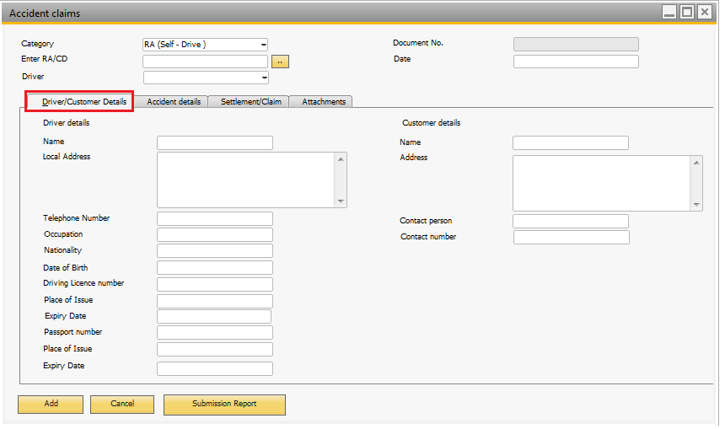

- Accident details Tab
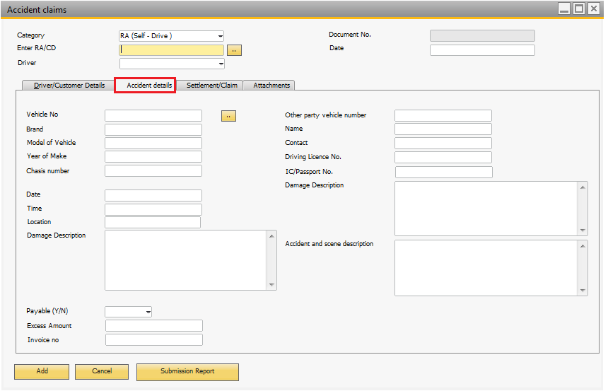

- Settlement/Claim Tab

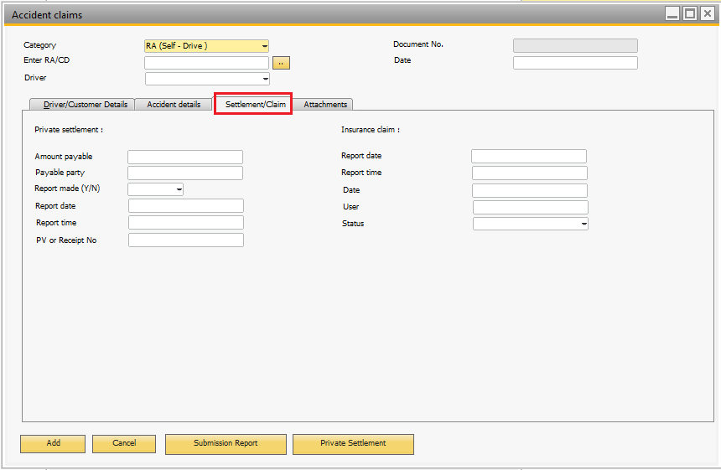

- Attachements Tab
Attach all the necessary documents related to Accident claims under this tab.

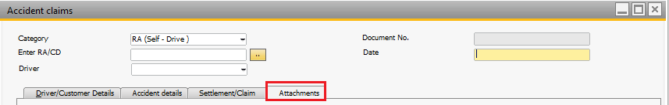

9.5 Service & Maintenance

Preventive maintenance
- Regular interval servicing
- Tires and batteries
- Polishing and detailing
- Corrective maintenance
- Breakdown
- Accident
- Reporting and Claim process

Email notification needs to be triggered based on types of Service & Maintenance.

Preventive maintenance (Report)

- General Service ( change oil , filters and engine maintenances)
>=10000 (Mileage) or 1 Yr.
- Battery
Based on time 2yrs
- Tires
- Based on mileage 40,000
- Wipers
- Based on time every 1 year

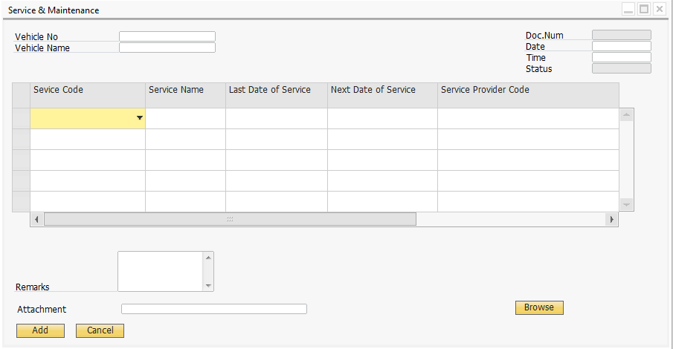

9.6 Sales Commission

RMG will pay the Sales Commission to Sales Persons as follows:

Chauffeur Drive Commission:
- For RMG Drivers – 1.75% of Amount billed to customer
- For External or Contractors – ( Amount billed – Total Cost) * 8%
- Commision needs to be calculated before GST.
- Anohter UI field in Booking/Billing : Commision and also another field to enter the cost.
- Specify the commision % in the Driver Master / External or Contractors profile

Self – Drive Commision :
- Long term contract commission will be : 1.75% * Monthly Rental Amount
- Short term will be 1.75% on Total Amount
- Commision needs to be calculated without GST.

Sales Commison report :
Report will be designed and developed according the format provided by RMG.

Parameters : one is less than 60days another >60 Days
Logic : Receipt advice Date – Invoice Date ( If more or less 60 Days)

9.7 Vehicle Tracking

This Module will be used to Track the Vehicles. Below are the steps to key in the vehicle IN & OUT details.
- Scan QR FOR VEH or enter manually via search OR BARCODE
- Vehicle IN or OUT
- Select Location
Location 1 - Base
Location 2 - Holiday
Location 3 - Mandarin
Location 4 - Others, Dempsey
Location 5 - workshop
- Workshop name
Rental/Replacement
- RA number
Chauffeur
Errand/operation
- Mileage
- Fuel level (Radio button E,1/4,1/2 and F)
- Overwrite date and time
- Scan NRIC

Vehicle Tracking Input UI:

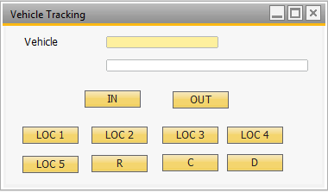

Popup:

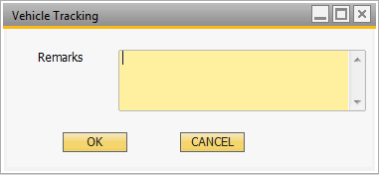

* Remarks required for 5,R and
# Optional for C & E

Popup:

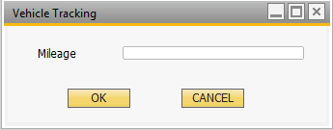

Popup:

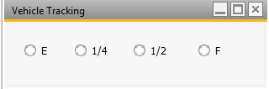

Popup:

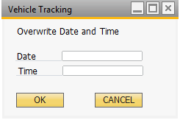
Popup:

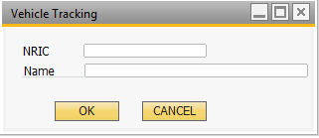
Click OK – End

Vehicle Tracking View – Real time update

[ Vehicle Live Status Display Screen ]

Out put 1 :

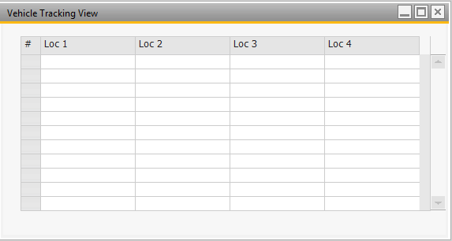

Output 2:

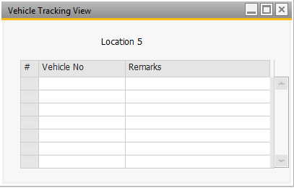

*** One more Screen
To show C & D

Vehicle No | Driver | Remarks

Price Setup

10.1 Base Price List

Pricing for Chauffeur Drive Services:

- RMG will maintain the price list based on the Transfer type
- Special price for customer
- Pricing will be different based on vehicle type
- System should calculate the surcharge based on the formula

Time out – Time in (roundup to 0.5hrs)
If the Time falls between 11pm to 7am.
Example : For transfer type – disposal $10 per hour: One way $25
If disposal (Time out – Time in) must be > 3 hours.

Price set up UI:

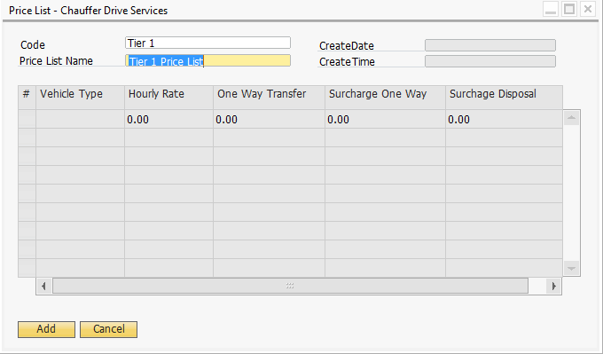

10.2 Special Price for Customer

RMG will provide special price for Customer. Price List will be configured in the Business Master data as separate User defined filed (UDF).

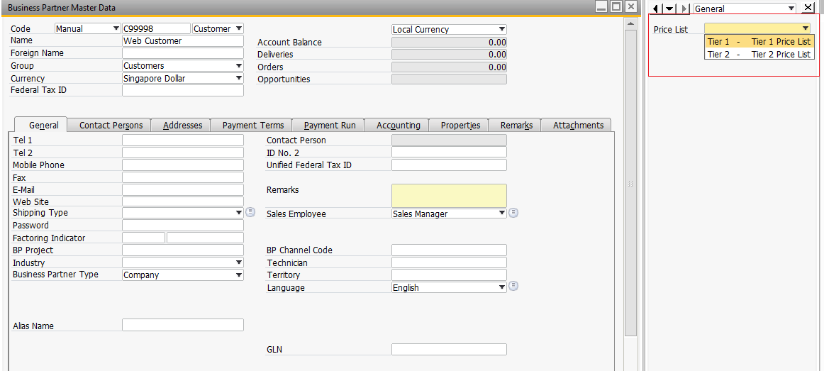

Note: The screenshot is for reference purpose, configuration will be done according to RMG Rent-A-Car Pte Ltd.

Acknowledgement

By signing this page, RMG Rent-A-Car Pte Ltd acknowledges that this document accurately represents the requirement of RMG Rent-A-Car Pte Ltd and that this document is the base for the system implementation.

Name | Department | Signature | Date

For and on behalf of Confirmed and Agreed by:
Abeo International Pte Ltd RMG Rent-A-Car Pte Ltd

_________________________________ _________________________________
Authorized Signature & Company Stamp Authorized Signature & Company Stamp

Name: Name:
________________________________ ________________________________

Title: Consulting Services Manager Title: Project Manager
________________________________ ________________________________

Date: Date:
________________________________ ________________________________

